WE ARE GOING TO VISIT DONEGAL CASTLE .IT IS A BEAUTIFULLY CASTLE COMPRISING A TOWER HOUSE WHICH HAS BEEN RESTORED TO IT’S FORMER GLORY AND AN ATTACHED MANOR HOUSE

THIS IS A PICTURE OF THE ENTRANCE TO DONEGAL CASTLE
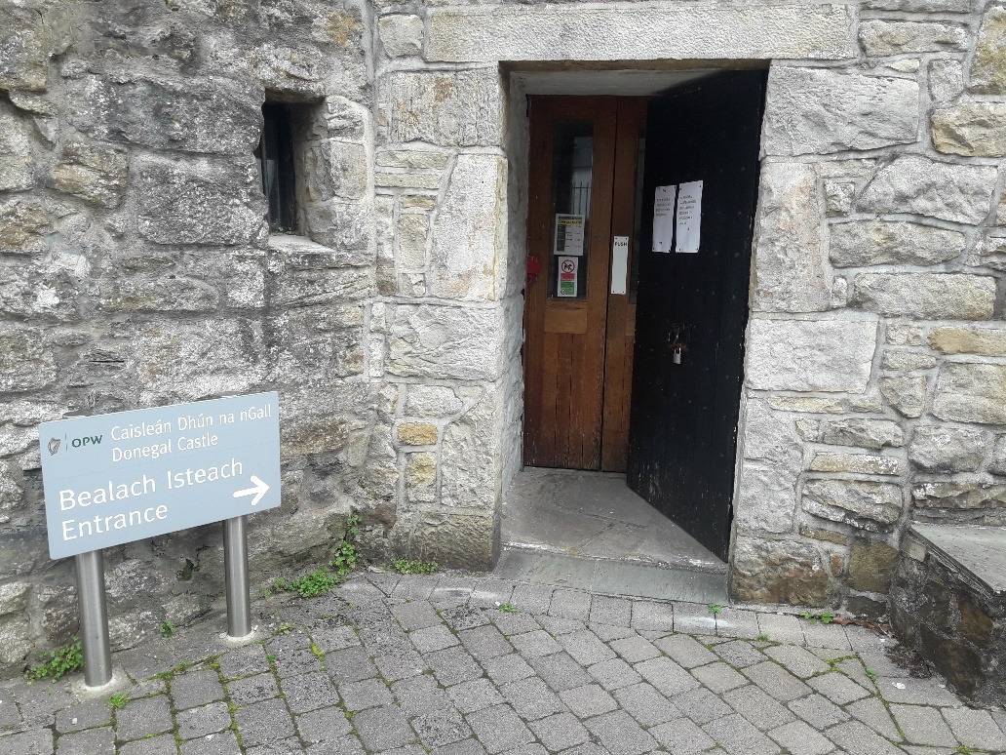
ENTERING THE CASTLE YOU STEP INTO OUR RECEPTION AREA AND VISITORS DESK. OUR GUIDES WILL MEET AND GREET YOU AND ADVISE YOU ON OUR GUIDED TOURS OR ALTERNATIVELY OFFER YOU A SELF GUIDE LEAFLET, WHICH WE HAVE IN A WIDE RANGE OF LANGUAGES. IF YOU HAPPEN TO ARRIVE DURING SOME OF OUR SPECIAL EVENTS SUCH AS HERITAGE WEEK YOU CAN EXPERIENCE SOME HISTORICAL RE- ENACTMENTS
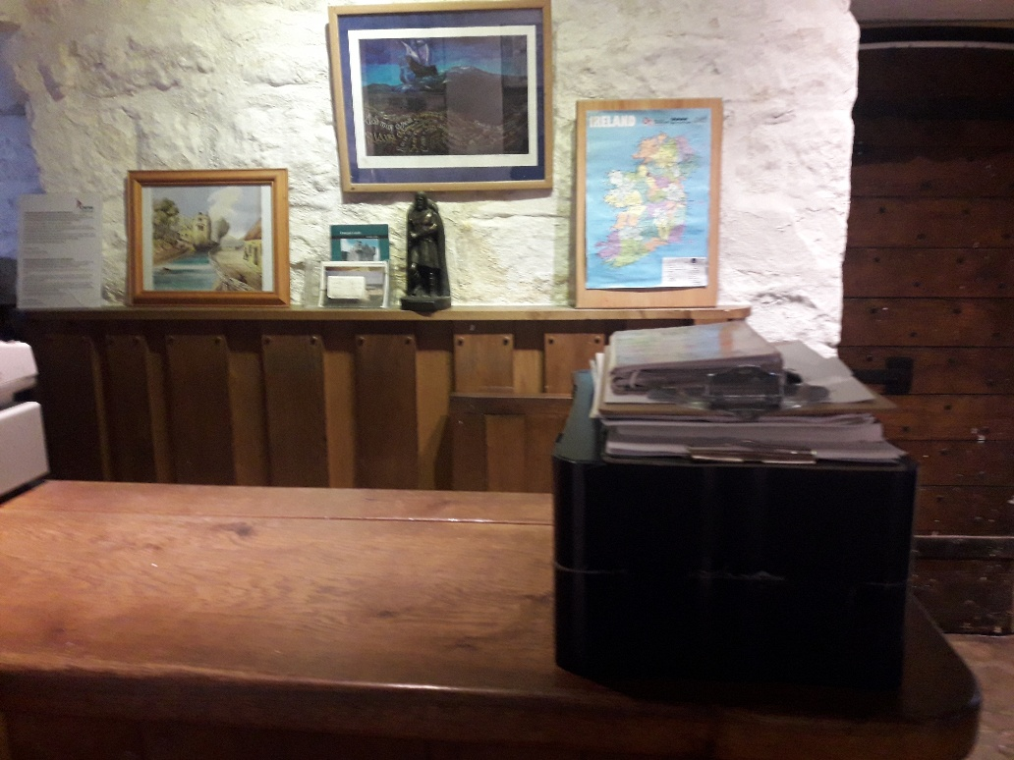
GUIDES IN PERIOD COSTUME
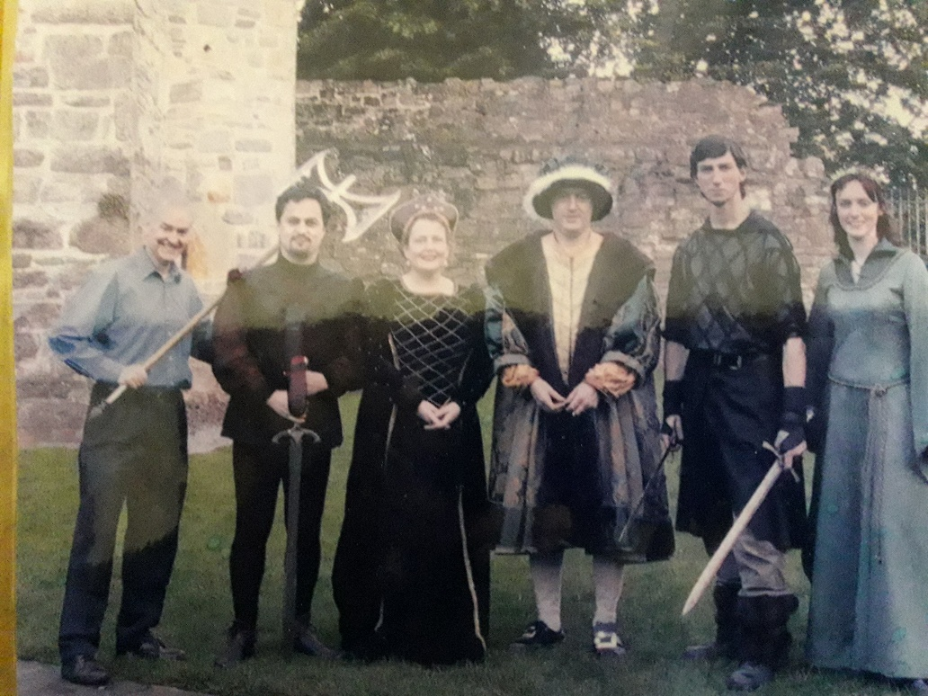

WE HAVE A LOVELY TREE STUMP SPECIALLY CARVED INTO THE SHAPE OF A THRONE. GREAT FOR ALL THOSE FAMILY PHOTOGRAPHS
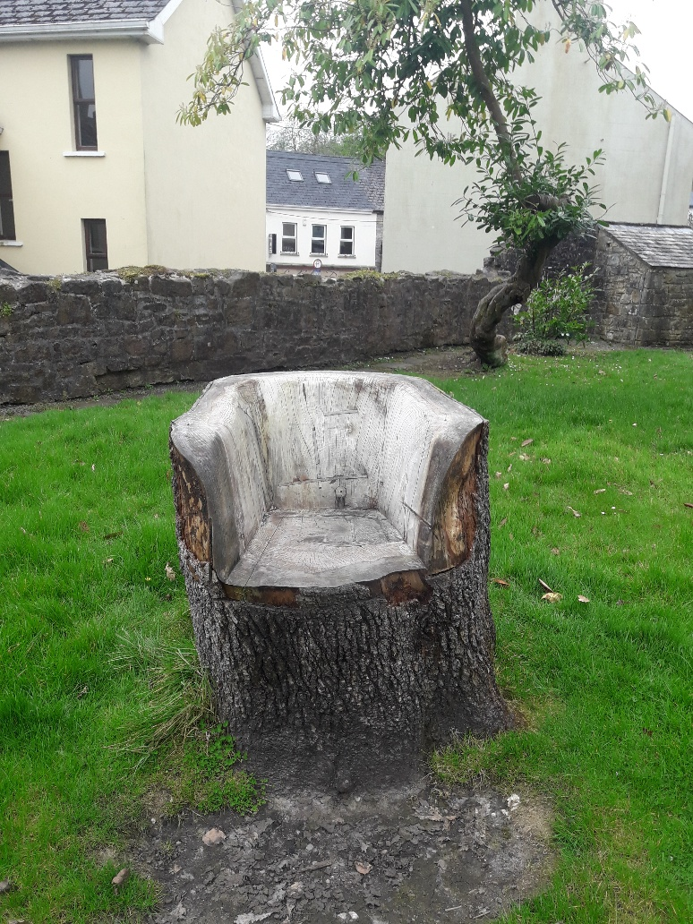
FOE THE CHILDREN WE HAVE A FUN TREASURE TRAIL.CAN YOU FIND ALL THE ITEMS AT THE CASTLE. TAKE CARE TO WALK SLOWLY AND NOT RUN IN CASE YOU FALL AND HURT YOURSELVES
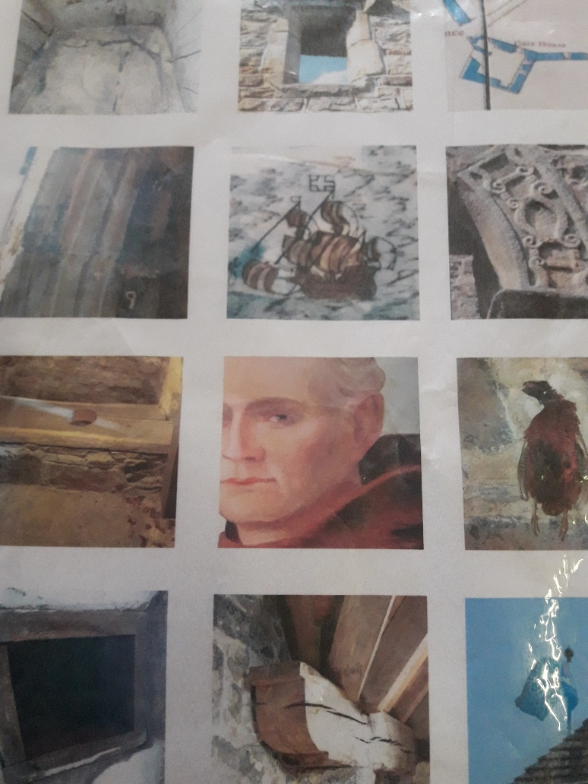
YOU ARE NOW STEPPING BACK IN HISTORY (THINK GAME OF THRONES) INTO THE CASTLE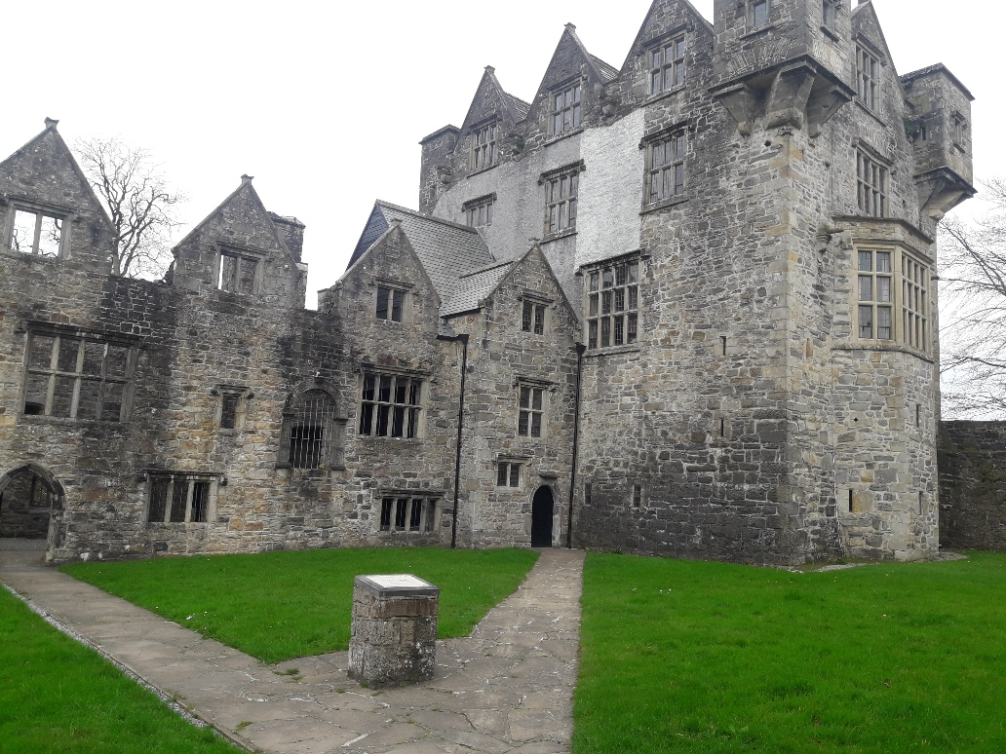
THE FAMILY WHO BUILT DONEGAL CASTLE WERE CALLED THE O DONNELLS A VERY FAMOUS AND POWERFUL IRISH CLAN. TO DEFEND THEIR CASTLE THEY BUILT THE STAIRWELL AT DIFFEREFT LEVELS TO TRIP UP THEIR ENEMY !!

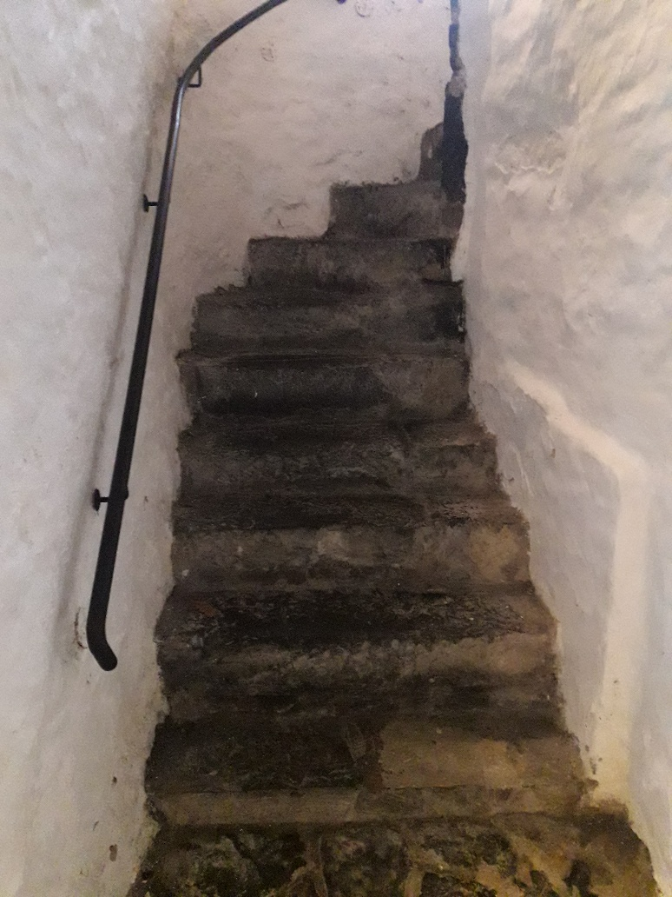
ON THE FIRST FLOOR YOU ENTER THE SPLENDED AND MAGNIFICENT BANQUETING HALL BUILT BY THE SECOND FAMILY WHO OCCUPIED DONEGAL CASTLE, THE BROOKE FAMILY
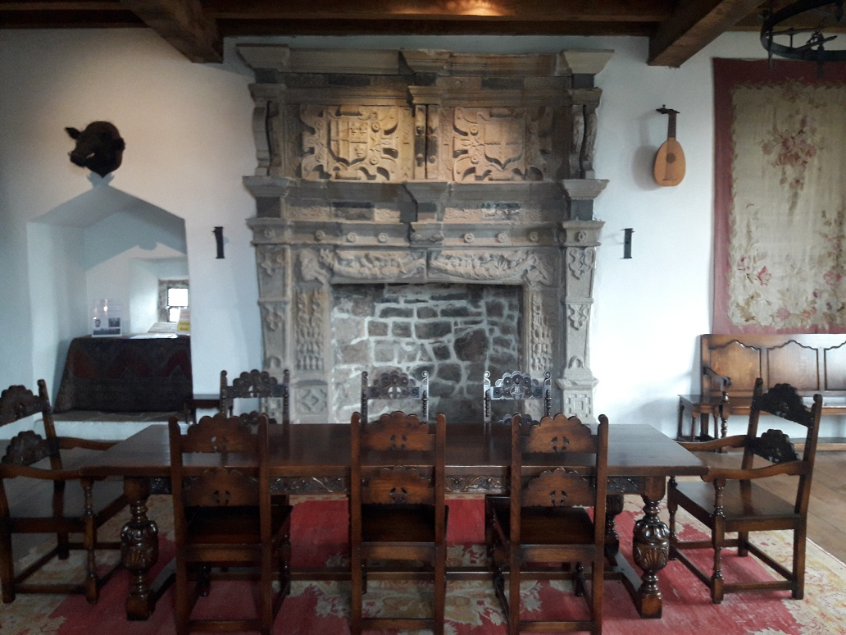
CLIMB THE NEXT SET OF STAIRS TO OUR EXHIBITION ROOM AND READ ALL ABOUT THE HISTORY OF DONEGAL CASTLE. YOU WILL SEE AN OPENING IN THE WALL.CAN YOU GUESS WHAT THAT WAS USED FOR.( ASK THE GUIDES WHEN YOU VISIT!!)

